SPARK
Understanding Spark Architecture
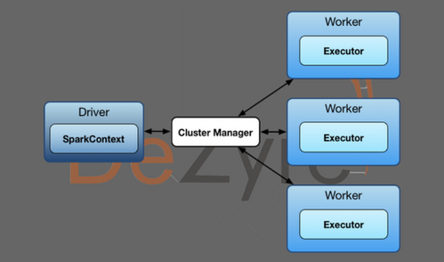
Apache Spark has a well-defined and layered architecture where all the spark components and layers are loosely coupled and integrated with various extensions and libraries. Apache Spark Architecture is based on two main abstractions-
- Resilient Distributed Datasets (RDD)
- Directed Acyclic Graph (DAG)

Resilient Distributed Dataset (RDD)
Resilient distributed dataset (RDD) is a spark core data-structure which holds data. It can be considered as an abstraction layer which holds multiple pieces of partitioned data as a single dataset. It is resilient because it can be re-built from the lineage graph or DAG created during the transformation phase by spark engine. So it there is a load failure, spark engine can always refer the lineage graph to re-create RDD.
It is distributed as below the abstraction layer, the data actually sits in a distributed fashion across multiple clusters. The underlying data is partitioned and the partitions are spread across multiple machines. This gives each node fewer data to work with, thus resulting in overall faster operation.

Directed Acyclic Graph (DAG)
Direct - Transformation is an action which transitions data partition state from A to B.
Acyclic -Transformation cannot return to the older partition
DAG is a sequence of computations performed on data where each node is an RDD partition and edge is a transformation on top of data. The DAG abstraction helps eliminate the Hadoop MapReduce multistage execution model and provides performance enhancements over Hadoop.

Spark Architecture Overview
Apache Spark follows a master/slave architecture with two main daemons and a cluster manager –
- Master Daemon – (Master/Driver Process)
- Worker Daemon –(Slave Process)
A spark cluster has a single Master and any number of Slaves/Workers. The driver and the executors run their individual Java processes and users can run them on the same horizontal spark cluster or on separate machines i.e. in a vertical spark cluster or in mixed machine configuration.

Spark Driver – Master Node of a Spark Application
It is the central point and the entry point of the Spark Shell (Scala, Python, and R). The driver program runs the main () function of the application and is the place where the Spark Context is created. Spark Driver contains various components – DAGScheduler, TaskScheduler, BackendScheduler and BlockManager responsible for the translation of spark user code into actual spark jobs executed on the cluster.
- The driver program that runs on the master node of the spark cluster schedules the job execution and negotiates with the cluster manager.
- It translates the RDD’s into the execution graph and splits the graph into multiple stages.
- Driver stores the metadata about all the Resilient Distributed Databases and their partitions.
- Cockpits of Jobs and Tasks Execution -Driver program converts a user application into smaller execution units known as tasks. Tasks are then executed by the executors i.e. the worker processes which run individual tasks.
- Driver exposes the information about the running spark application through a Web UI at port 4040.

Spark Executor
Executor is a distributed agent responsible for the execution of tasks. Every spark applications has its own executor process. Executors usually run for the entire lifetime of a Spark application and this phenomenon is known as “Static Allocation of Executors”. However, users can also opt for dynamic allocations of executors wherein they can add or remove spark executors dynamically to match with the overall workload.
- Executor performs all the data processing.
- Reads from and Writes data to external sources.
- Executor stores the computation results data in-memory, cache or on hard disk drives.
- Interacts with the storage systems.

Cluster Manager
An external service responsible for acquiring resources on the spark cluster and allocating them to a spark job. There are 3 different types of cluster managers a Spark application can leverage for the allocation and deallocation of various physical resources such as memory for client spark jobs, CPU memory, etc. Hadoop YARN, Apache Mesos or the simple standalone spark cluster manager either of them can be launched on-premise or in the cloud for a spark application to run.
Choosing a cluster manager for any spark application depends on the goals of the application because all cluster managers provide different set of scheduling capabilities. To get started with apache spark, the standalone cluster manager is the easiest one to use when developing a new spark application.

What happens when Spark Job is submitted?
When a client submits a spark user application code, the driver implicitly converts the code containing transformations and actions into a logical directed acyclic graph (DAG). At this stage, the driver program also performs certain optimizations like pipelining transformations and then it converts the logical DAG into physical execution plan with set of stages. After creating the physical execution plan, it creates small physical execution units referred to as tasks under each stage. Then tasks are bundled to be sent to the Spark Cluster.

The driver program then talks to the cluster manager and negotiates for resources. The cluster manager then launches executors on the worker nodes on behalf of the driver. At this point the driver sends tasks to the cluster manager based on data placement. Before executors begin execution, they register themselves with the driver program so that the driver has holistic view of all the executors. Now executors start executing the various tasks assigned by the driver program. At any point of time when the spark application is running, the driver program will monitor the set of executors that run. Driver program in the spark architecture also schedules future tasks based on data placement by tracking the location of cached data. When driver programs main () method exits or when it call the stop () method of the Spark Context, it will terminate all the executors and release the resources from the cluster manager.
The structure of a Spark program at higher level is - RDD's are created from the input data and new RDD's are derived from the existing RDD's using different transformations, after which an action is performed on the data. In any spark program, the DAG operations are created by default and whenever the driver runs the Spark DAG will be converted into a physical execution plan.
Dataframes
Spark dataframes are distributed collection of data in rows and columns. It is the structured representation of data similar like a table. We can say dataframes are relational database tables with better optimization.

Persistence
All spark computations are presented as lineage graphs. Different parts of job computations are connected by dependencies and computations are lazy. To trigger a computation, you have to call an action on RDD or dataframe, for example: count. This makes Spark start computation from the beginning of the graph and compute the result step by step, partition by partition. The point here is that if you have the same lineage and you call another action collect(), spark will re-compute the whole graph even though nothing has changed. And this thing can be really bad for several types of computations, for example, if you have an iterative algorithm which loops through stable pre-computed data like machine-learning algorithm. That's why Spark provides you with a method to actually store intermediate results of a computation, and this is called persist.
RDD and dataframe has a persist function which actually allows you the option to safe keep/store intermediate transformations applied on a dataframe/RDD in either memory or disk IO and this is called persist. When you persist, you have to choose where to persist the data. There are three kinds of storage levels available in pi Spark. The preferable one is MEMORY_ONLY, your executor has some reserved memory for persisting and when you choose MEMORY_ONLY, Spark tries to save partitions in this part of memory if there is enough space. There is also a MEMORY_ONLY_2 option, which provides a bit of redundancy by storing two replicas on different cluster nodes. The second level is MEMORY_AND_DISK. Basically, Spark tries to store as much of data as possible in memory and if there is not enough space, it will spill records to disk. This, however, introduces performance considerations because disks IO is pretty slow.
So, what do you have to keep in mind when using persistence? Spark is an in-memory framework and you have to keep it so for the best performance. That's why store your partitions in memory if they fit. And even if it does not fit, you should probably think about increasing the memory of your executors.
Checkpoints
And finally, if you use some kind of iterative algorithm like machine-learning algorithm in case of all specialization, you should definitely think of persisting the results of intermediate computations like training dataset. Okay, as I have already mentioned, when you persist, intermediate results are stored in the memory of an executor or in disk of an executor. So actually, if an executor fails, Spark has to re-compute partitions of the particular executor from scratch, but your cluster can be really crowded by different jobs and users and the resource manager will not allocate new containers for this re-computation. This situation may dramatically increase the running time of your job. That's why Spark provides you with the mechanism of a reliable persistence called checkpointing. When you checkpoint, Spark writes partitions of an RDD or a dataframe to a reliable storage and this storage is HDFS. And another interesting thing with checkpointing is that it also turnkeys the whole lineage graph which produced this intermediate result. To make a checkpoint, you need to specify a directory in HDFS where to store the data and then call checkpoint method of an RDD. And the caveat here is that you can't checkpoint a dataframe. For a dataframe, you have to checkpoint the underlying RDD. So, want to make a checkpoint? You should definitely think about checkpointing in a noisy cluster. Cluster is called noisy if there are lots of jobs and users which compete for resources and there are not enough resources to run all the jobs simultaneously. You must think about checkpointing if your computations are really expensive and take long time to finish because it could be faster to write an RDD to HDFS and read it back in parallel than recompute from scratch. And there's a slight inconvenience; there is no way to checkpoint a dataframe so you have to checkpoint the underlying RDD. So, to sum up, in this video, you learned that Spark provides ways to store intermediate results by persisting or checkpointing. It helps to speed up several kinds of workloads like iterative algorithms in general and machine-learning algorithms in particular. You have learned that persisting is unreliable. If an executor fails, Spark has to recompute its partitions and checkpointing is reliable because it stores data in a reliable HDFS. Now, you also know that checkpointing is slow because you have to write data to HDFS, and persisting may be slow if you use not only the memory, but the disks for persisting, as well.

How to specify optimum no. of executor cores and executor memory for a Spark Job execution?
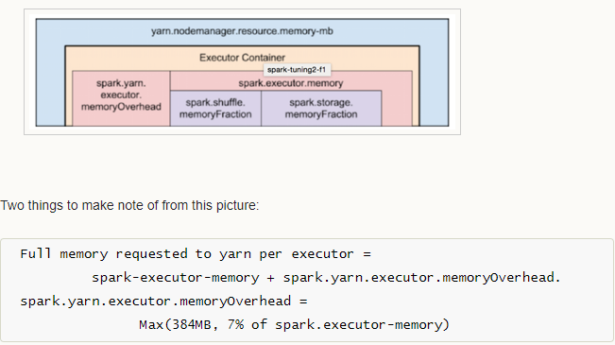
Let’s assume we have Hadoop cluster with the below configuration:
10 nodes
16 cores per node
64 GB RAM per node

TOTAL CORES= 10 * 16 = 160

Approach 1 TINY executors:
If we allocate 1 core for 1 executor, total no of executors= 160,
Then total memory for each executor= 640/160= 4GB

But 4GB of memory for 1 executor is less, and should be avoided. NOT GOOD

Approach 2 FAT executors:
FAT executors generally means 1 executor per node. Thus, in this case,
10 nodes = 10 executors
1 executor = 160/10= 16 cores
1 executor memory = 640/10= 64GB

Thus, with FAT executors, we have each executor with 16 cores and 64GB of ram

Approach 3 Intermediate approach (balance between fat and tiny):
1. Lets assign 5 cores to each executors, ideal for HDFS throughput.
2. Leave 1 core from each node for yarn/hadoop deamons. So, total cores available per node= 16-1= 15
3. Total cores available= 15*10= 150
4. Total no of executors= 150 cores/5 cores = 30 executors
5. Leave 1 executor out of 30 executors for application manager. So, --num-executors= 29
6. Number of executors per node= 30/10= 3
7. Memory per executor= 64/3= 21GB
8. Counting off heap overhead= 7% of 21GB = 3GB. So, actual memory: --executor-memory= 21-3= 18GB

So, recommended configuration is: 29 executors, 18GB memory each and 5 cores each!!

So, --num-executors= 29 --executor-memory= 18GB

